

Travlr Getaways Website

CS 465 Project Software Design Document
Version 1.0

Table of Contents

CS 465 Project Software Design Document 1
Table of Contents 2
Document Revision History 2
Instructions 2
Executive Summary 3
Design Constraints 3
System Architecture View 3
Component Diagram 3
Sequence Diagram 4
Class Diagram 4
API Endpoints 4
The User Interface 4

Document Revision History

Version | Date | Author | Comments
1.0 | <03/21/26> | <Andrew Allen> | Initial iteration via milestone One;  Updated the Executive Summary, Design Constraints, and System Architecture View sections

Instructions

Fill in all bracketed information on page one (the cover page), in the Document Revision History table, and below each header. Under each header, remove the bracketed prompt and write your own paragraph response covering the indicated information.

Executive Summary

Travlr Getways is designed for use as an online web application, consisting of a user interface structured as a MVC pattern. MVC (model view controller) serves as a template that separates the interface components into three different layers of logic. The m layer (model) is what interacts with the database. While the model layer includes data retrieval and storage, it also includes how the data will be manipulated under the standards of included business logic. For Travlr, this may include manipulation for booking data for the user, or for a higher privileged user to credit points for an average member. As for the database itself, this application utilizes mongoDB (a noSQL database). mongoDB stores and holds data/information in a binary version of JSON called BSON. The controller itself does not directly engage with the databases, so the controller instead will send requests to the model. The model will then retrieve and either accomplish or deny those requests through returning data back to the controller.

Express is used as a backend framework for this application, which contains the folder structures, routes, and acts as the HTTP framework for the server. Angular is used as the clientside framework, which makes sense as this is a single page application. Because this is not a content or data heavy website, clientside rendering makes more sense. Node.JS is used for the server-side, which allows for a single language stack (the MEAN stack relies on only javascript).

The administrator Single-page applications (SPA) may have access to various tools that a member or customer will not have access to. This can include CRUD functionality, and contains an additional layer of security via restrictive permissions granted through authentication. The administrative SPA CRUD will allow for the ability to cancel(delete)/ manage(update) user bookings, finalize bookings, and also give them the ability to retrieve prior bookings (read).

The SPA is also mutually beneficial for the customer/ client, as the website itself should be more responsive. Single page applications allow for small portions of the website to render without the client needing to make a pass for html or request data through a server round trip. As for functionality specifically, the application will allow users to view various travel packages, explore different locations of each travel package, and also view the features included for each package. Price points should also be disclosed as well. An administrative SPA should also be available to cancel/ manage user bookings, finalize bookings, and give them the ability to pull up previous finalized sales to help users with any information needed.

Design Constraints

Security:
Security is a difficult constraint to handle, as it is impossible to perfect, and is more tailored around the strength that provides sufficient coverage. Security is judged on a curve decided by both the owners of the application as well as the expectations of the users. No client would want their personal protected information leaked, and a leak would break trust between the client and the owner. A client expects some base level guarantee to interact with the application. For the owner, this security should adhere to legal and legislative standards. Payment processing information, client information (PPI like phone number, home address, birthdate, the window of time they will be away from home) must have industry standard protection from common attack vectors within the industry.

Scalability:
Scalability is possible with the MEAN stack, as node.JS can handle an abundance of connections. This web application should be able to serve thousands of users at the same time, with database adjustments (horizontal scaling via sharding) that allow for efficient queries from users. These queries may not be as efficient as a multiple page application with search engine optimization, however it should still serve clients information within a desired time constraint.

Monetary/ time factors for development:
More granular or specific additions may be prohibitively expensive based on budget. The necessary features associated with a functioning web application are first order. Additional features may be added at a later date, after the completion of the application. From a monetary perspective on costs for the stack itself, this is not an issue. All of the stack is open source, meaning that resources can be allocated elsewhere.

Payment Processing
Payment processing could be externalized to some modular API for the point of sale. This is crucial, as Travlr needs some sort of payment processing to generate revenue. Third party processing comes with its own pros and cons, but escaping the culpability of a failed payment processing is nice. If the third party were to go down or have a leak, it is on the third party as well, so the blame is shared.

Inherent issues/integration:
As discussed earlier, the MEAN stack uses javascript explicitly. Since javascript is the only used language, it is confined to the constraints of javascript.

Database
MongoDB is a noSQL database, which comes with both pros and cons due to its unique properties. While mongoDB features support that allows for it, NoSQL databases lack ACID (Atomicity, Consistency, Isolation, Durability) principals but run on BASE BASE (Basically Available, Soft state, Eventual consistency) principals. Transactional stability is not inherently necessary for reserving a hotel. However, I can imagine it to be quite frustrating to lose a transaction for a vacation package due to some bug or issue for both the travlr employees as well as the client whose vacation is lost.

Component Diagram

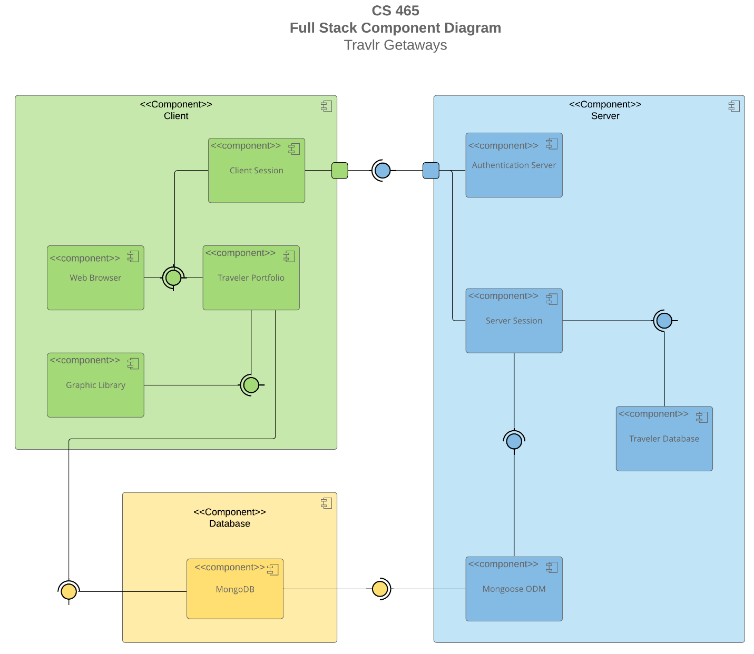

System Architecture View

The three components shown are as follows: Client, Server, Database
The client component is the customer/user of the application. This is who the application really is built for. The client begins by opening their web browser and initiating an authenticated session by inputting their login credentials. Each client will have access to their traveler portfolio, which may make requests based on user generated queries to the database component.
The server component consists of server side logic. The client’s credentials go through the server by initiating a new server session. The server then interacts with the database through Mongoose ODM. The server also handles all of the logic associated with any third party APIs (like the payment processing if implemented).
The database will receive requests from the client through the server side. The server component translates each request via Mongoose ODM. Mongoose ODM will map the javascript objects into mongo documents. These Mongo documents can also be turned back into javascript objects, and these objects are what are viewed by the client.

Sequence Diagram
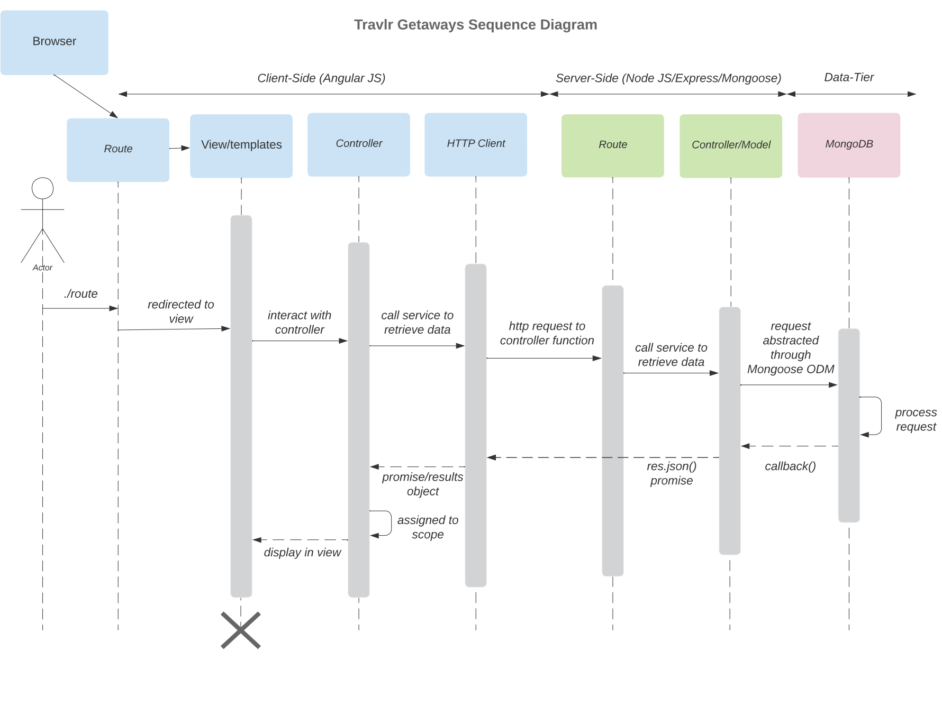
I started with a difference between the initial sequence diagram, allowing for the first step where the user accesses the browser before navigating to our application. After entering the url or clicking on a link from another platform/web browser, the user will then be redirected based on routes. This will initially redirect the user to the home page, with user requests creating different routes dependent on the user’s requests. Once the route path is detected, it will select the appropriate template/view for the user. The view part of the MVC (model view controller) makes a call and asks the controller for some data. The controller itself cannot access the data,but instead calls an HTTP client. The client makes an http request to the backend for the data. The server then handles the request via an express route, which forwards it back to the controller. This controller is the server side controller, which is different from the MVC. This controller will interact with the database through Mongoose ODM (which acts as an abstraction). The database will then complete and process the request, which starts the flow of this data backwards. The fetched data then does a callback to the controller, and is routed back as a server response. The client catches the response, the data is passed to the MVC, and the user receives this information in their view.

Class Diagram
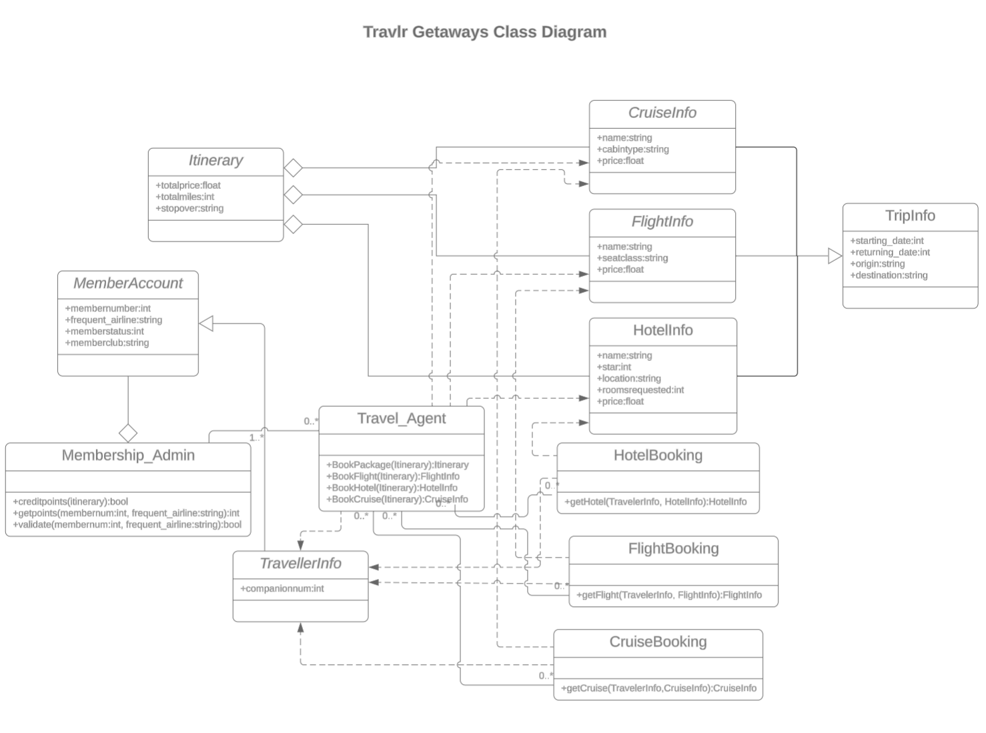
Description of Diagram specifics:
A class diagram has different symbols to denote something specific. The plus denotes what portions of a class(or maybe all of the class) are public. This is useful for implementation, as deciding which attributes are public or private while creating the application could result in conflicts between merges, or unresolved scope issues. Lines with diamonds represent a concept called aggregation. This will become relevant later on. Filled black arrows with lines that are dashed are used for what is called usage dependency. This explains how the class may inherit other attributes from a different class.

Class Diagram details:
Industry standards go a long way for this diagram. Because this diagram adheres to these standards, it creates a more intuitive environment, where the requirement collection period can be showcased cleanly to the people that want the application completed. To begin, the trip Info class is a “whole class”. This means that it has an aggregated relation with respect to other classes. There are three of these aggregated relationships: Flight info, Hotel info, and Cruise info. These three all have dependencies being the booking portions (HotelBooking, Flightbooking, Cruisebooking). In order for a representative or user to book an event, the booking function requires information for the booking to commence. Each one correlates the info to the booking, as you would not need hotel info to book a cruise. These are within the purview of inheritance within the itinerary class. These info classes use the “is a” clause, because they borrow attributes from the superclass that is known as itinerary. They have both departure and return timeframes, and locations of departures and the vacationing spot. The type of vacation doesn’t matter, as they all have this information in common.

After looking at the booking/ info classes, we can now get into how those bookings are accessed and created. The travel agent class is dependent on the booking classes, as the travel agent makes the bookings for the user. This is a certain type known as a “bi-directional” association. This is because the instances of the classes are related to each other. Each type of the three bookings require “traveller info”, and this information is obtained from the travel agent class. The travel agent obtains this information inherited from the various info classes (the three info classes discussed earlier). So, when a getter is is getting information for a booking, it is doing so through the travel agent class. Without this information, the getters would not be able to get anything, and the booking would not be tailored or work properly. The booking requires the total number of travellers, account information specific to each booking for the user, as well as what dates would be preferred. All of these associations so far can be described as “direct associations” meaning that these structured to interact with each other in accordance to how they are supposed to function. The 0 with .. and * symbolize the quantity of associations between the two. 0..* means zero to many, which explains that none of the info may be required, but all of it may also b e required to be shared amongst the classes.
Finally, we can talk about the member account class. This is an aggregated portion of membership admin. Member account class will hold all of the information of the user. This privileged information is available to the administrative class, along with access to read/update/delete this information. While members can change some information on their own, they may require some administrator delegated with membership responsibility to alter or remove certain information. This is also not done the same way an administrator may interact with CRUD on an account. The traveler agent does not have cart blanche access to the member class, meaning some privileged information they do not need for booking will be abstracted away or restricted from reading. The agents only have access to the traveler info class.

API Endpoints

Method | Purpose | URL | Notes
GET | template/view for all the rooms | /api/rooms | Showcases all of the potential rooms a user could look at
GET | Displays view for one specific room | /api/rooms/room_type/rroom_ID | displays cost, amenities provided, and pros about the room/ size of room(bed size)
GET | Displays news from the owners of the website | /api/news | Shows potential exciting new events/vacations, deals, and other information that the owners may want to tell users
GET | Meal template selection | /api/meals/meal_select/meal_ID | Shows specific meal, with cost/ ingredients/ other factors for meal
GET | View for showing all meals | /api/meals | Showcases all of the potential meals a user can expect to have
GET | view/template for all of the location examples | /api/travel/travel_list | Showcases a list of all potential locations
GET | Displays specific location | /api/travel/travel_list/travel_location | Showcases one specific location, with a descriptor of potential activities/itinerary, and price range for location
PUT | edit user information | /api/travel/users/member_ID/edit | Updates existing information for user including name change, username change, password change, payment processing change
PUT | Trip editor/rescheduler | /api/travel/trip/trip_ID/edit | Updates and edits an already planned trip by changing dates/amount of people staying/ length of stay
POST | Create a new account | /api/users/register | Allows for inputting new information to create a user profile for someone that does not have an account
POST | Login credentials | /api/users/login | Returning authentication and validation for users that need to access the website again
PATCH | Update website with new functionality/ bug fixes | /api/users/update | Changes get made to the website, and they are presented with patch notes to the user
DELETE | removes/ deletes filters presently selected | /api/travel/trips/trip_filters | Applying filters manipulates data presented to the user. This option will reset the data to a standard set of results
DELETE | Removes an established trip | /api/travel/trips/trip_ID | Removal of a trip that was already established

The User Interface

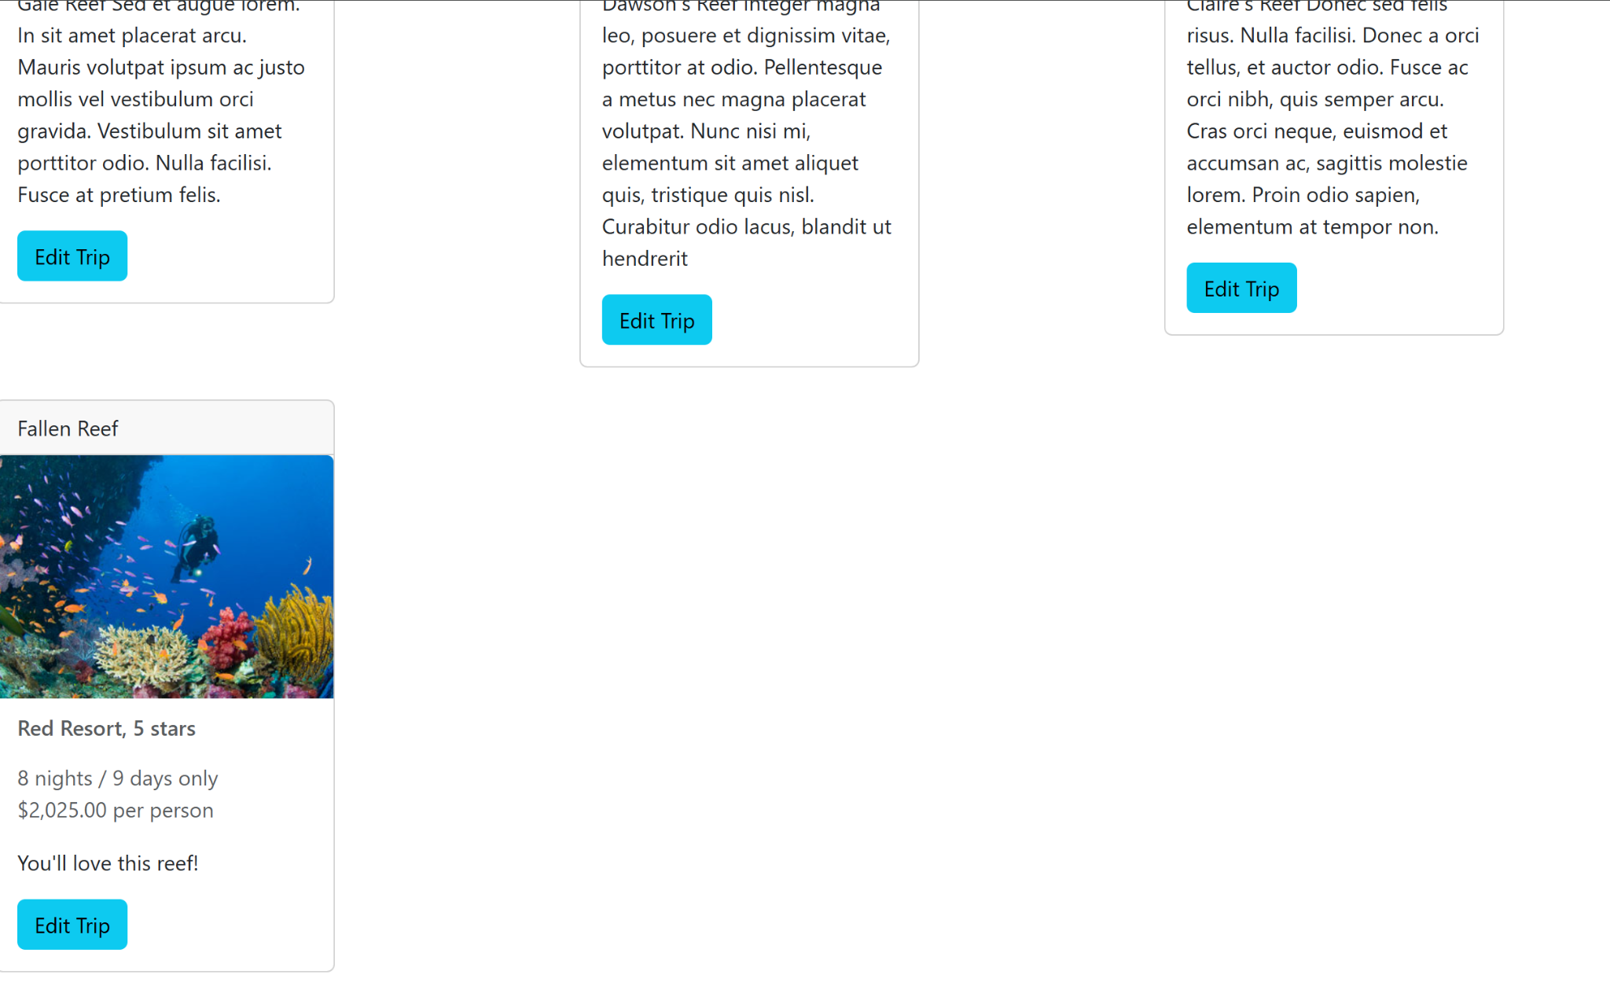
I added the trip Fallen Reef
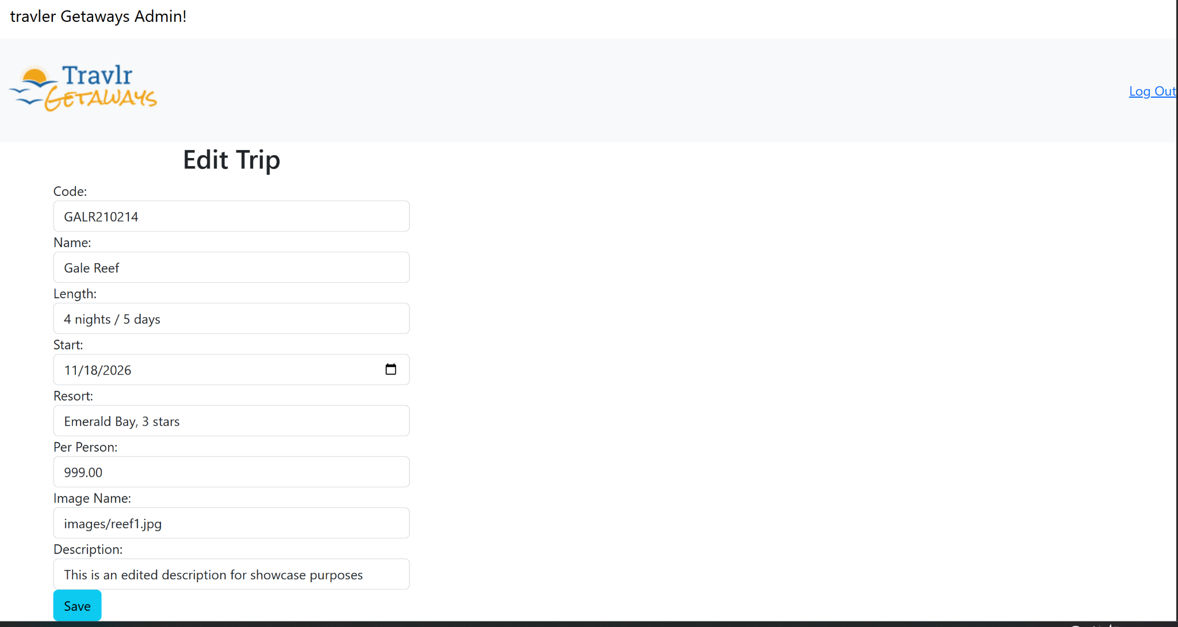
Here is a showcase with an edited date, cost, and description. Below is the original trip
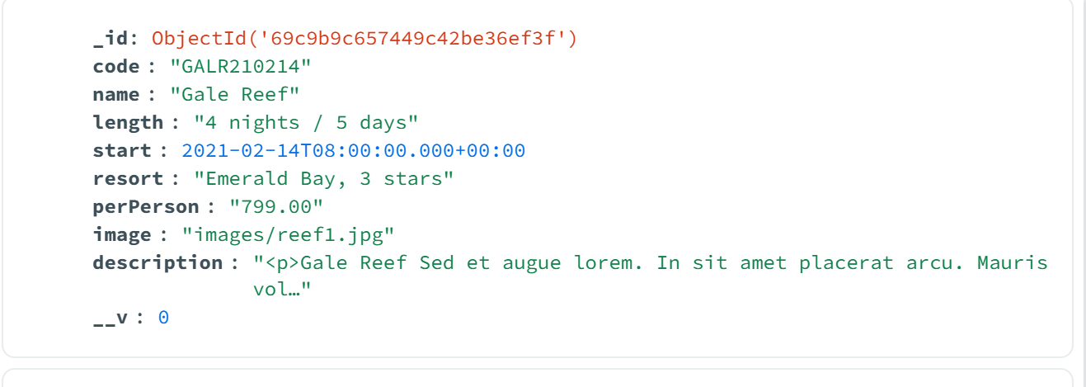
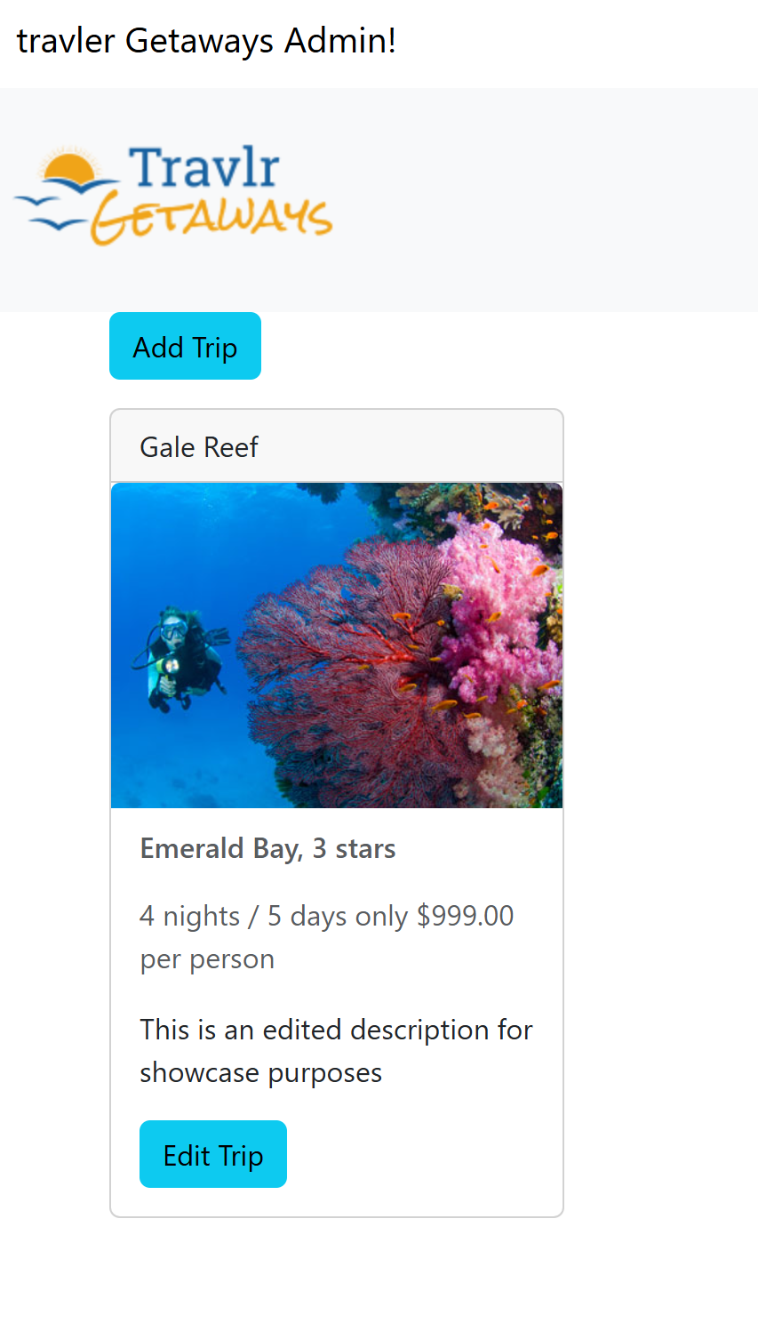
Here is the edited trip, along with the new json document in MongoDB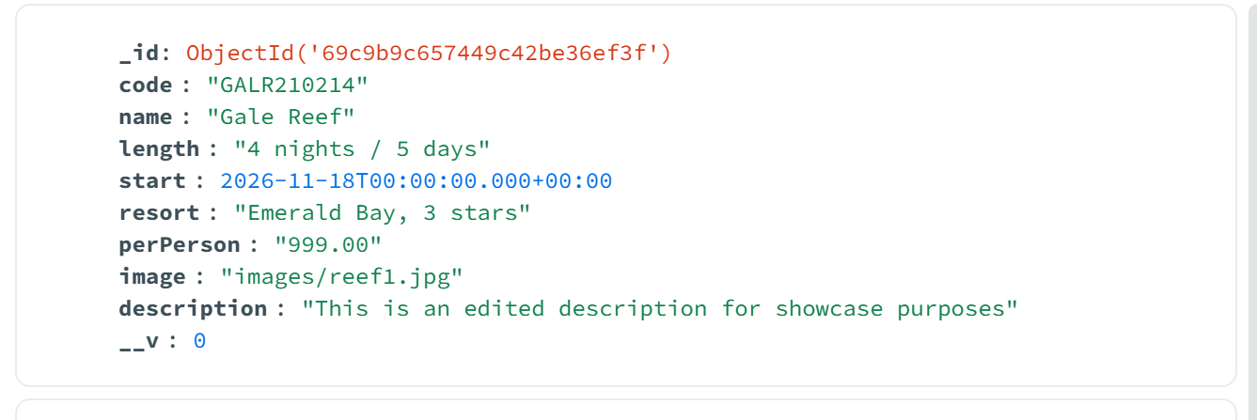

The angular project differs from the Express html in a couple of different ways. The express page was created using express (and handlebars to serve dynamic templates). User requests were handled using controllers and routes. The routes dictate the view of the user and are handled server-side, with the view that is displayed to the user is a template. This means that the browser receives a completed page of HTML each time the user goes to visit a different page. Alternatively, dynamic pages exist rather than static, which allows the server to populate via data injection through handlebars templates to certain portions of a page with information from a database.
An angular application is only loaded one time, rather than each time a new view is chosen. This is why it is named a “single page application”. Rather than loading HTML repeatedly, it is only loaded once. What happens when interacting with the SPA? Well, when the user interacts with the application, the content is rendered client-side. The same goes for navigation and rendering. This is a meaningful difference, as the only time calls to the backend of the application are made are for database requests(like CRUD). An example of this with the angular project involves the edit or add trip portions of the SPA. Angular applications are also separated into components, services, and models. This application features a lot of components which comprise the user interface. Services are used for API calls,dependency injections, and implementation of logic. The models are structures for data in the database (i.e, the user, trip, and auth response).
Some of the errors I ran into while attempting to test the SPA prevented me from even accessing the user interface of the SPA in the first place. Route mismatches, missing exported members, and unauthorized errors would prevent portions of the application from working altogether or display a blank page. Even with a directive to help build this application, it was still not an easy feat. One example of this includes the login portion. This worked inside postman, but it did not work within angular due to the token not correctly attaching to API calls. One issue that I had as well included an unseen space inside of a saved email within MongoDB. This was causing login issues, and formatting issues like these would need to be addressed before rolling out an application as a live service. Postman, Inspect element/ developer tools, as well as mongo compass were all instrumental in ensuring the SPA worked correctly. Once everything was correctly configured, utilizing the website itself and monitoring with the developer tools allowed for assurance that the SPA meets all of its intended functionality.

